Q1) Identify the Data type for the Following:

|  |  |
| --- | --- |
| Activity | Data Type |
| Number of beatings from Wife | Discrete |
| Results of rolling a dice | Discrete |
| Weight of a person | Continuous |
| Weight of Gold | Continuous |
| Distance between two places | Continuous |
| Length of a leaf | Continuous |
| Dog's weight | Continuous |
| Blue Color | Discrete |
| Number of kids | Discrete |
| Number of tickets in Indian railways | Discrete |
| Number of times married | Discrete |
| Gender (Male or Female) | Discrete |

Q2) Identify the Data types, which were among the following

Nominal, Ordinal, Interval, Ratio.

|  |  |
| --- | --- |
| Data | Data Type |
| Gender | Nominal |
| High School Class Ranking | Ordinal |
| Celsius Temperature | Interval |
| Weight | Ratio |
| Hair Color | Nominal |
| Socioeconomic Status | Ordinal |
| Fahrenheit Temperature | Interval |
| Height | Ratio |
| Type of living accommodation | Nominal |
| Level of Agreement | Ordinal |
| IQ(Intelligence Scale) | Interval |
| Sales Figures | Ratio |
| Blood Group | Nominal |
| Time Of Day | Ordinal |
| Time on a Clock with Hands | Interval |
| Number of Children | Ratio |
| Religious Preference | Nominal |
| Barometer Pressure | Interval |
| SAT Scores | Interval |
| Years of Education | Ratio |

Q3) Three Coins are tossed, find the probability that two heads and one tail are obtained?

Solution: Three coins are tossed, the combinations are: HHH, THH, HTH ,HHT,TTH,THT,HTT,TTT. Total number of outcomes is 8.

The number of combinations which have two heads and one tail are: THH,HTH,HHT which makes them 3 in number.

P = number of combinations having two heads and one tail **/** Total number of combinations

P = 3 / 8

P = 0.375

Q4) Two Dice are rolled, find the probability that sum is

Solution:

N(s) = 36

Number of possible out comes

Possible Outcomes

{(1,1),(1,2),(1,3),(1,4),(1,5),(1,6),

(2,1),(2,2),(2,3),(2,4),(2,5),(2,6),

(3,1),(3,2),(3,3),(3,4),(3,5),(3,6),

(4,1),(4,2),(4,3),(4,4),(4,5),(4,6),

(5,1),(5,2,),(5,3),(5,4),(5,5),(5,6),

(6,1),(6,2),(6,3),(6,4),(6,5),(6,6)}

1. equal to 1

Soln: Two Dice are rolled probability that sum is equal to 1 is zero

Because the outcomes are in this format i.e.(1,1),(1,2),….

P=0

b)Less than or equal to 4

Soln: The sum is equal to 4 possible outcomes are (1,1),(1,2),(1,3),(2,1),(2,2),(3,1)

P = possible outcomes / N(s)

P = 6 / 36 = 1 / 6

P = 0.16

c)Sum is divisible by 2 and 3

Soln: Probability of outcomes-{(1,1),(1,2),(1,3),(1,5),(2,1),(2,2),(2,4),(2,6), (3,1),(3,3),(3,5),(3,6),(4,2),(4,4),(4,5),(4,6),(5,1),(5,3),(5,4),(5,5), (6,2),(6,3),(6,4),(6,6)}

P=24/36=4/6=2/3

P=0.66

Q5) A bag contains 2 red, 3 green and 2 blue balls. Two balls are drawn at random. What is the probability that none of the balls drawn is blue?

Soln: total no of balls=7 balls

n(S)= 2 balls drawn out of 7

7C2=21

n(S1)= 2 balls drawn non of is blue

5C2=10

P(S1)=7C2/5C2

=21/10

P(S1)=2.1

Q6) Calculate the Expected number of candies for a randomly selected child

Below are the probabilities of count of candies for children (ignoring the nature of the child-Generalized view)

|  |  |  |
| --- | --- | --- |
| CHILD | Candies count | Probability |
| A | 1 | 0.015 |
| B | 4 | 0.20 |
| C | 3 | 0.65 |
| D | 5 | 0.005 |
| E | 6 | 0.01 |
| F | 2 | 0.120 |

Child A – probability of having 1 candy = 0.015.

Child B – probability of having 4 candies = 0.20

Soln: E= **Expected number of candies for a randomly selected child**

P(E)= 1 * 0.015  + 4*0.20  + 3 *0.65  + 5*0.005  + 6 *0.01  + 2 * 0.12

= 0.015 + 0.8  + 1.95 + 0.025 + 0.06 + 0.24

P(E)=3.09

Q7) Calculate Mean, Median, Mode, Variance, Standard Deviation, Range & comment about the values / draw inferences, for the given dataset

* For Points,Score,Weigh>

Find Mean, Median, Mode, Variance, Standard Deviation, and Range and also Comment about the values/ Draw some inferences.

Soln:

|  |  |  |  |
| --- | --- | --- | --- |
|  | Points | Score | Weigh |
| Mean | 3.596 | 3.217 | 17.848 |
| Median | 3.695 | 3.325 | 17.71 |
| Mode | 3.891 | 3.54 | 17.43 |
| Variance | 0.285 | 0.957 | 3.19 |
| Standard Deviation | 0.534 | 0.978 | 1.786 |
| Range | 2.76,4.93 | 1.513,5.424 | 14.5,22.9 |

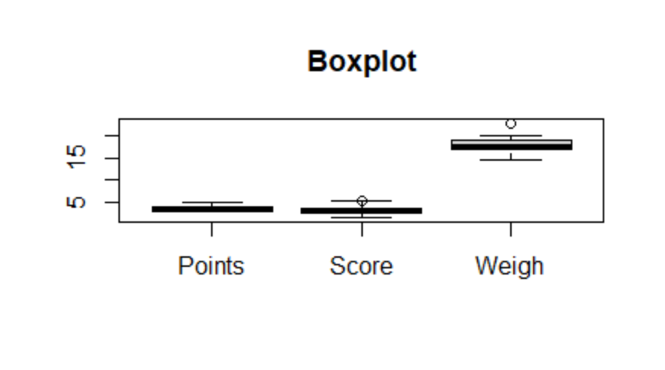

|  |  |  |
| --- | --- | --- |
| Points | Score | Weigh |
| 3.9 | 2.62 | 16.46 |
| 3.9 | 2.875 | 17.02 |
| 3.85 | 2.32 | 18.61 |
| 3.08 | 3.215 | 19.44 |
| 3.15 | 3.44 | 17.02 |
| 2.76 | 3.46 | 20.22 |
| 3.21 | 3.57 | 15.84 |
| 3.69 | 3.19 | 20 |
| 3.92 | 3.15 | 22.9 |
| 3.92 | 3.44 | 18.3 |
| 3.92 | 3.44 | 18.9 |
| 3.07 | 4.07 | 17.4 |
| 3.07 | 3.73 | 17.6 |
| 3.07 | 3.78 | 18 |
| 2.93 | 5.25 | 17.98 |
| 3 | 5.424 | 17.82 |
| 3.23 | 5.345 | 17.42 |
| 4.08 | 2.2 | 19.47 |
| 4.93 | 1.615 | 18.52 |
| 4.22 | 1.835 | 19.9 |
| 3.7 | 2.465 | 20.01 |
| 2.76 | 3.52 | 16.87 |
| 3.15 | 3.435 | 17.3 |
| 3.73 | 3.84 | 15.41 |
| 3.08 | 3.845 | 17.05 |
| 4.08 | 1.935 | 18.9 |
| 4.43 | 2.14 | 16.7 |
| 3.77 | 1.513 | 16.9 |
| 4.22 | 3.17 | 14.5 |
| 3.62 | 2.77 | 15.5 |
| 3.54 | 3.57 | 14.6 |
| 4.11 | 2.78 | 18.6 |

**Use Q7.csv file**

Q8) Calculate Expected Value for the problem below

1. The weights (X) of patients at a clinic (in pounds), are

108, 110, 123, 134, 135, 145, 167, 187, 199

Assume one of the patients is chosen at random. What is the Expected Value of the Weight of that patient?

Soln:Mean of weights are =108+110+123+135+145+167+187+199 / 9

Mean = 1308 / 9

Mean = 145.33

The expected value of the weight of that patient which is chosen random is 145.33

**Q9) Calculate Skewness, Kurtosis & draw inferences on the following data**

**Cars speed and distance**

**Use Q9_a.csv**

|  |  |
| --- | --- |
| speed | dist |
| 4 | 2 |
| 4 | 10 |
| 7 | 4 |
| 7 | 22 |
| 8 | 16 |
| 9 | 10 |
| 10 | 18 |
| 10 | 26 |
| 10 | 34 |
| 11 | 17 |
| 11 | 28 |
| 12 | 14 |
| 12 | 20 |
| 12 | 24 |
| 12 | 28 |
| 13 | 26 |
| 13 | 34 |
| 13 | 34 |
| 13 | 46 |
| 14 | 26 |
| 14 | 36 |
| 14 | 60 |
| 14 | 80 |
| 15 | 20 |
| 15 | 26 |
| 15 | 54 |
| 16 | 32 |
| 16 | 40 |
| 17 | 32 |
| 17 | 40 |
| 17 | 50 |
| 18 | 42 |
| 18 | 56 |
| 18 | 76 |
| 18 | 84 |
| 19 | 36 |
| 19 | 46 |
| 19 | 68 |
| 20 | 32 |
| 20 | 48 |
| 20 | 52 |
| 20 | 56 |
| 20 | 64 |
| 22 | 66 |
| 23 | 54 |
| 24 | 70 |
| 24 | 92 |
| 24 | 93 |
| 24 | 120 |
| 25 | 85 |

**Ans.**

|  |  |  |
| --- | --- | --- |
| **skewness** | **-0.1139548** | **0.7824835** |
| **kurtosis** | **2.422853** | **3.248019** |

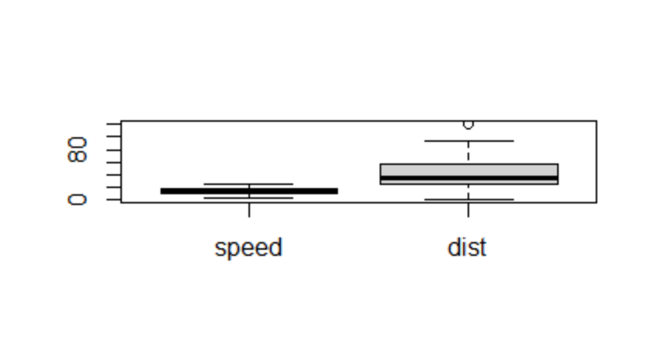

**SP and Weight(WT)**

**Use Q9_b.csv**

|  |  |
| --- | --- |
| SP | WT |
| 104.1854 | 28.76206 |
| 105.4613 | 30.46683 |
| 105.4613 | 30.1936 |
| 113.4613 | 30.63211 |
| 104.4613 | 29.88915 |
| 113.1854 | 29.59177 |
| 105.4613 | 30.30848 |
| 102.5985 | 15.84776 |
| 102.5985 | 16.35948 |
| 115.6452 | 30.92015 |
| 111.1854 | 29.36334 |
| 117.5985 | 15.75353 |
| 122.1051 | 32.81359 |
| 111.1854 | 29.37844 |
| 108.1854 | 29.34728 |
| 111.1854 | 29.60453 |
| 114.3693 | 29.53578 |
| 117.5985 | 16.19412 |
| 114.3693 | 29.92939 |
| 118.4729 | 33.51697 |
| 119.1051 | 32.32465 |
| 110.8408 | 34.90821 |
| 120.289 | 32.67583 |
| 113.8291 | 31.83712 |
| 119.1854 | 28.78173 |
| 114.5985 | 16.04317 |
| 120.7605 | 38.06282 |
| 119.1051 | 32.83507 |
| 99.56491 | 34.48321 |
| 121.8408 | 35.54936 |
| 113.4846 | 37.04235 |
| 112.289 | 33.23436 |
| 119.9211 | 31.38004 |
| 121.3926 | 37.57329 |
| 111.289 | 32.70164 |
| 115.0131 | 31.91122 |
| 114.0934 | 28.754 |
| 116.9094 | 27.87992 |
| 116.9094 | 28.6305 |
| 128.4613 | 30.11543 |
| 116.3926 | 37.39252 |
| 115.7488 | 35.02718 |
| 117.4613 | 30.52743 |
| 114.0934 | 28.34398 |
| 114.381 | 33.07863 |
| 117.1051 | 32.62192 |
| 118.2087 | 36.49862 |
| 116.4729 | 33.91006 |
| 127.9094 | 28.0706 |
| 118.289 | 33.45847 |
| 118.289 | 33.21395 |
| 118.289 | 33.43671 |
| 120.4043 | 40.39816 |
| 143.3926 | 37.62069 |
| 135.3926 | 37.25439 |
| 126.4043 | 40.58907 |
| 110.4613 | 30.14754 |
| 118.289 | 32.73452 |
| 112.6452 | 30.61528 |
| 115.5766 | 37.66287 |
| 130.2087 | 36.88815 |
| 117.6685 | 37.86041 |
| 126.0481 | 43.39099 |
| 125.3123 | 40.72283 |
| 128.1284 | 40.15948 |
| 126.5985 | 15.71286 |
| 132.4846 | 37.97996 |
| 133.6802 | 41.57397 |
| 133.3123 | 40.47204 |
| 158.3007 | 37.14173 |
| 164.5985 | 15.82306 |
| 133.416 | 44.01314 |
| 133.1401 | 43.35312 |
| 124.7152 | 52.99775 |
| 121.8642 | 42.6187 |
| 132.8642 | 42.77822 |
| 169.5985 | 16.13295 |
| 150.5766 | 37.92311 |
| 151.5985 | 15.76963 |
| 167.9445 | 39.4231 |
| 139.8408 | 34.94861 |

**Ans:**

|  |  |  |
| --- | --- | --- |
|  | **SP** | **WT** |
| **skewness** | **1.581454** | **-0.6033099** |
| **kurtosis** | **5.723521** | **3.819466** |

**Q10) Draw inferences about the following boxplot & histogram**



Ans:

Histogram shows us positive that is right skewed data.

Boxplot shows us there is outliers in given data.

**Q11)** Suppose we want to estimate the average weight of an adult male in Mexico. We draw a random sample of 2,000 men from a population of 3,000,000 men and weigh them. We find that the average person in our sample weighs 200 pounds, and the standard deviation of the sample is 30 pounds. Calculate 94%,98%,96% confidence interval?

Ans. confidence Interval = **‾X ± Z(S ÷ √n)**

Z(alpha)= 0.94,0.96,0.98

X = 200

**(S ÷ √n)= (30/2000**0.5)**

**import** numpy **as** np

**import** pandas **as** pd

**from** scipy **import** stats

**from** scipy.stats **import** norm

*# Avg. weight of Adult in Mexico with 94% CI*

stats**.**norm**.**interval(0.94,200,30**/**(2000**\*\***0.5))

(198.738325292158, 201.261674707842)

*# Avg. weight of Adult in Mexico with 98% CI*

stats**.**norm**.**interval(0.98,200,30**/**(2000**\*\***0.5))

(198.43943840429978, 201.56056159570022)

*# Avg. weight of Adult in Mexico with 96% CI*

stats**.**norm**.**interval(0.96,200,30**/**(2000**\*\***0.5))

(198.62230334813333, 201.37769665186667)

|  |  |  |
| --- | --- | --- |
| **confidence interval** | **Z value** | **Range** |
| confidence interval94% | 1.880794 | 198.74,201.26 |
| confidence interval96% | 2.053749 | 198.62,201.38 |
| confidence interval98% | 2.326348 | 198.43,201.56 |

**Q12)** Below are the scores obtained by a student in tests

**34,36,36,38,38,39,39,40,40,41,41,41,41,42,42,45,49,56**

1. Find mean, median, variance, standard deviation.

Ans:

|  |  |
| --- | --- |
| Mean | 41 |
| Median | 40.5 |
| Variance | 25.52 |
| Standard deviation | 5.05664 |

1. What can we say about the student marks?

Ans: 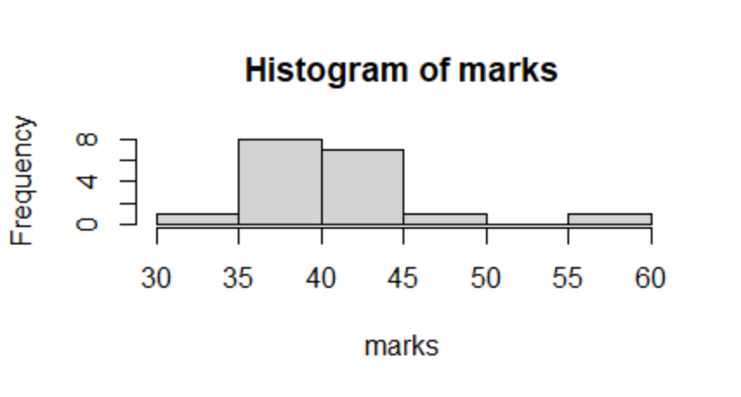

There is outlier in student marks. No student can get marks between 51-55, mass of student marks between 38-42.

Q13) What is the nature of skewness when mean, median of data are equal?

Ans: Data is normalized and there is no skewness.

Q14) What is the nature of skewness when mean > median ?

Ans. The distribution is positively skew or right skew.

Q15) What is the nature of skewness when median > mean?

Ans. The distribution is negatively skew or left skew.

Q16) What does positive kurtosis value indicates for a data ?

Ans. Positive kurtosis value indicates the thinner peak and wider tails.

Q17) What does negative kurtosis value indicates for a data?

Ans. Negative kurtosis value indicates that wider peak and thinner tails.

Q18) Answer the below questions using the below boxplot visualization.



What can we say about the distribution of the data?

Ans. Not normally Distributed.

What is nature of skewness of the data?

Ans. Negative Skewness.

What will be the IQR of the data (approximately)?   
Ans. 10-18

Q19) Comment on the below Boxplot visualizations?



Draw an Inference from the distribution of data for Boxplot 1 with respect Boxplot 2.

Ans. Both Boxplot are Normally Distributed and there is no Outliers in both Boxplot. There are large datapoints in Boxplot 2 as compared to Boxplot 1.

Q 20) Calculate probability from the given dataset for the below cases

Data _set: Cars.csv

Calculate the probability of MPG of Cars for the below cases.

MPG <- Cars$MPG

Ans. Mean (MPG) = 34.422075728024666

Std (MPG) = 9.131444731795982

* 1. P(MPG>38)

1-stats.norm.cdf(38,34.42,9.13) = 0.34748702501304063

* 1. P(MPG<40)

stats.norm.cdf(40,34.42,9.13) = 0.7294571279557076

* 1. P (20<MPG<50)

stats.norm.cdf(20,34.42,9.13)-(1-stats.norm.cdf(50,34.42,9.13)) = 0.013160161501873442

Q 21) Check whether the data follows normal distribution

1. Check whether the MPG of Cars follows Normal Distribution

Dataset: Cars.csv

Ans.

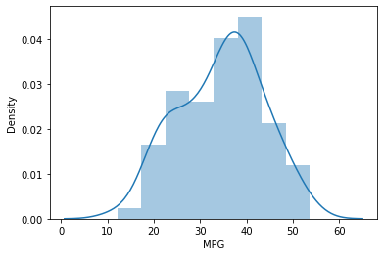

The MPG of car follows Normal Distribution.

1. Check Whether the Adipose Tissue (AT) and Waist Circumference(Waist) from wc-at data set follows Normal Distribution

Dataset: wc-at.csv

Ans.

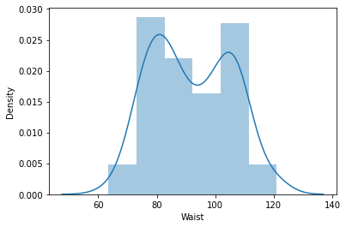

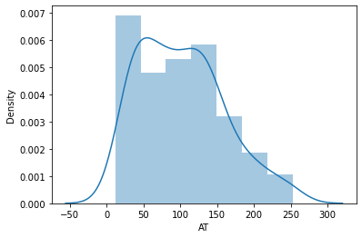

From above graphs the Adipose Tissue (AT) and Waist Circumference(Waist) from wc-at data set not follows Normal Distribution.

Q 22) Calculate the Z scores of 90% confidence interval,94% confidence interval, 60% confidence interval

Ans. **from** scipy **import** stats

*# Z-score of 90% confidence interval*

stats**.**norm**.**ppf(0.95)

1.6448536269514722

*# Z-score of 94% confidence interval*

stats**.**norm**.**ppf(0.97)

1.8807936081512509

*# Z-score of 60% confidence interval*

stats**.**norm**.**ppf(0.8)

0.8416212335729143

Q 23) Calculate the t scores of 95% confidence interval, 96% confidence interval, 99% confidence interval for sample size of 25

**from** scipy **import** stats

*# t scores of 95% confidence interval for sample size of 25*

stats**.**t**.**ppf(0.975,24) *# df = n-1 = 24*

2.0638985616280205

*# t scores of 96% confidence interval for sample size of 25*

stats**.**t**.**ppf(0.98,24)

2.1715446760080677

*# t scores of 99% confidence interval for sample size of 25*

stats**.**t**.**ppf(0.995,24)

2.796939504772804

Q 24**)** A Government company claims that an average light bulb lasts 270 days. A researcher randomly selects 18 bulbs for testing. The sampled bulbs last an average of 260 days, with a standard deviation of 90 days. If the CEO's claim were true, what is the probability that 18 randomly selected bulbs would have an average life of no more than 260 days

Hint:

rcode 🡪 pt(tscore,df)

df 🡪 degrees of freedom

Ans. t-stat for data is given as below

t = x- μ/ s/sqrt.n

x=260

μ =270

s=90

n=18

t=(260-270) /(90/squrt.18)

t=(-10*squrt.18)/90

t=(-10*4.24)/90

t=-0.471

from scipy import stats

stats.t.cdf(- 0.471,17)

probability that 18 randomly selected bulbs would have an average life of no more than 260 days is 0.3218